Hw2 GridWorld 309833027

1. value of random movement

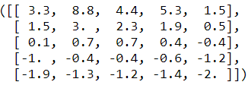

1. rule of my policy



只允許往上或往下走。

1. value of my policy

